LOT  05450 | hola  fghfgh  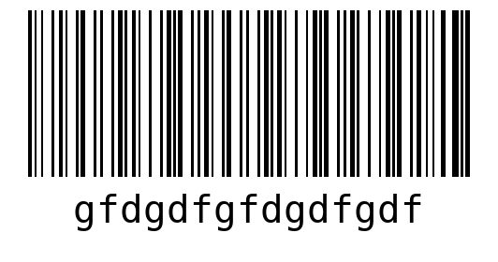  WO fhghgffg  LOT 05450  QTY 10

SHEET  1 | hola  fghfgh  WO fhghgffg  LOT 05450
hola  fghfgh  WO fhghgffg  LOT 05450 | SHEET  2
hola  fghfgh  WO fhghgffg  LOT 05450 | hola  fghfgh  WO fhghgffg  LOT 05450

hola  fghfgh  WO fhghgffg  LOT 05450 | hola  fghfgh  WO fhghgffg  LOT 05450
hola  fghfgh  WO fhghgffg  LOT 05450 | SHEET  3
hola  fghfgh  WO fhghgffg  LOT 05450 | hola  fghfgh  WO fhghgffg  LOT 05450

hola
fghfgh
WO fhghgffg
LOT 05450

